BERNESE 5.2: TIME SERIES WITH DISPLACEMENT
TO DETERMINE THE COSEISMIC DISPLACEMENT
INPUT: PLOT/SITE FILES IN “PLOTS” folder
1. Copy the plot file/s to a folder. e.g MILA (text file from “PLOTS” folder to c:\Displacement\
2. Copy RUN_ENU.py to the folder you created. e.g to c:\Displacement\
3. Open and edit the plot file/s. Put “COSEISMIC” as the first column on the selected date/s. e.g
2020.6324 is the date of the event
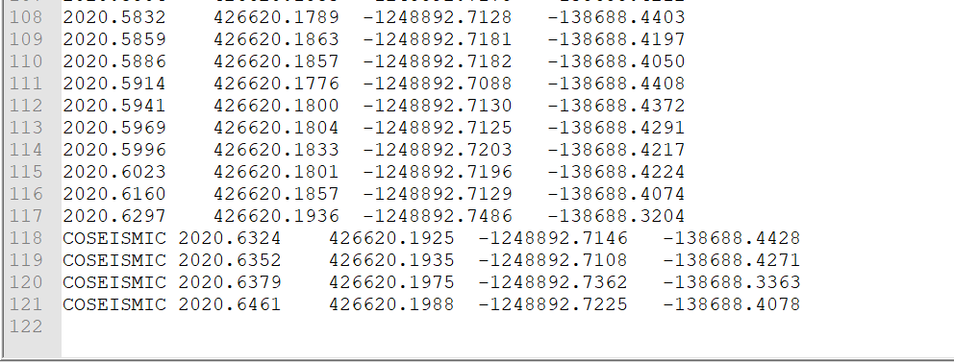
4. RUN RUN_ENU.py by double clicking the PY file. Input site name.
OUTPUT: SITE_D.jpg and SITE_D (text file)
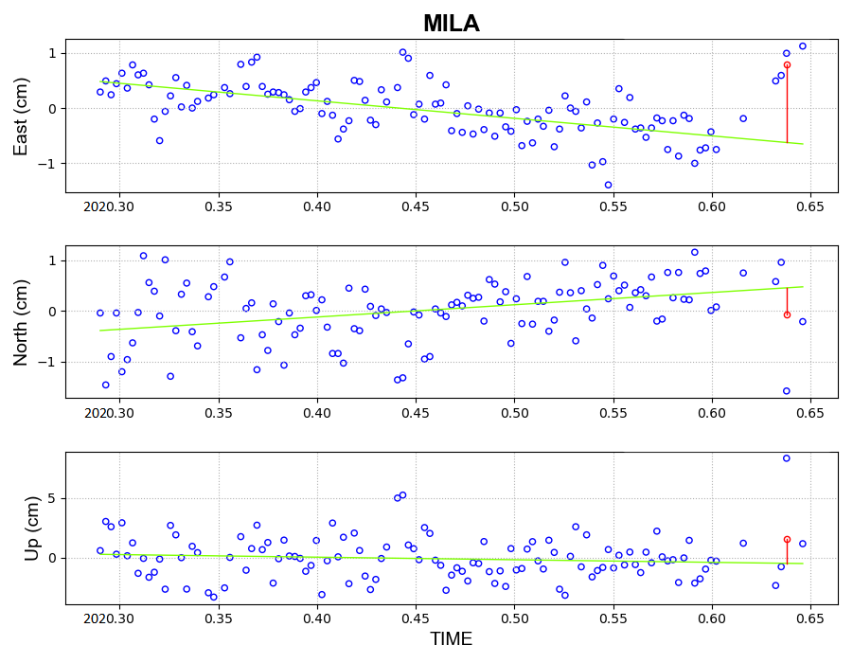
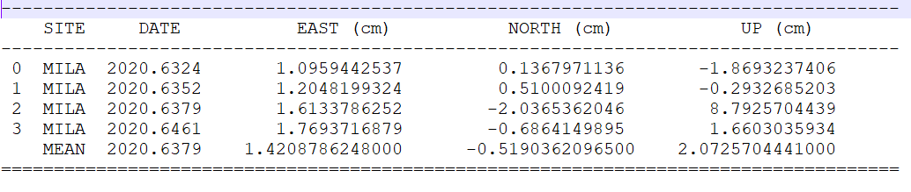

Done! :)

LAST UPDATE: NOVEMBER 17, 2021 3:00 PM

